Small Business Network Design 1 switch

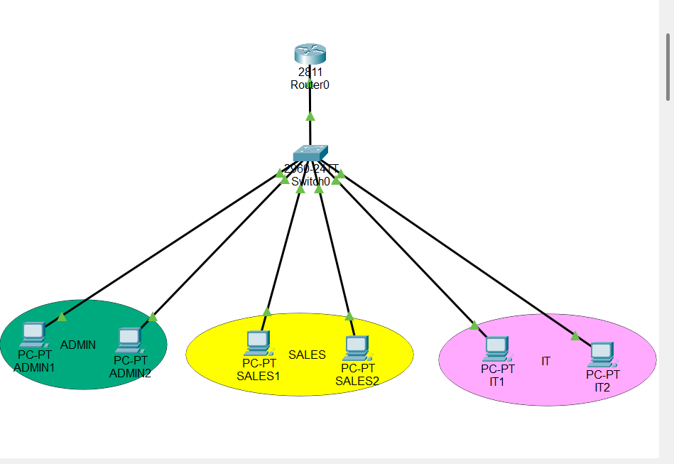

3 departments: Admin, Sales, and IT
Task: You are to set up VLANs for each department and configure inter-VLAN routing to enable communication between them.

- Add Network Devices and Identification with color codes
- Cisco 2811 Router (1)
- Cisco 2960 switch (1)
- End Device - PC (6)

- Connect Network Devices with copper straight-through cable.
- Assign IP Addresses and Default gateways

VLAN 10 (Admin): 192.168.10.0/24. VLAN 20 (Sales): 192.168.20.0/24. VLAN 30 (IT): 192.168.30.0/24
- Determine IP Address Class and Subnetting
- A class C IP Address (Usually preferred for medium to small sized networks) and it ranges from 192.0.0.0 to 223.255.255.255.
Assign static IPs (e.g., 192.168.10.2) and set the Default Gateway to the router's sub-interface (e.g., 192.168.10.1).
- Router config.
Configure Router-on-a-Stick.
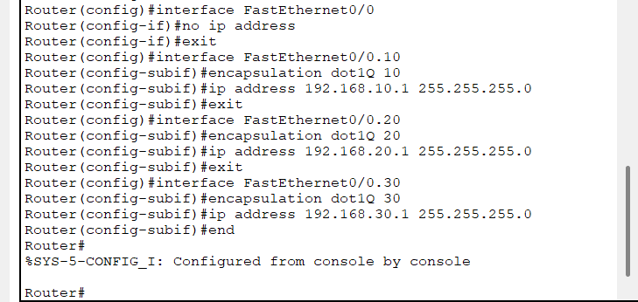
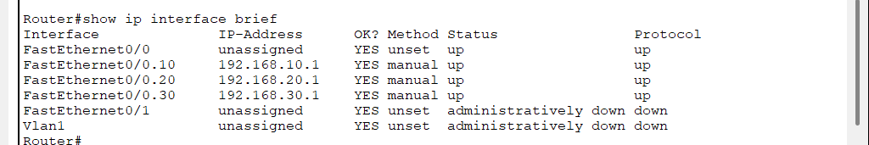
- VLAN Setup
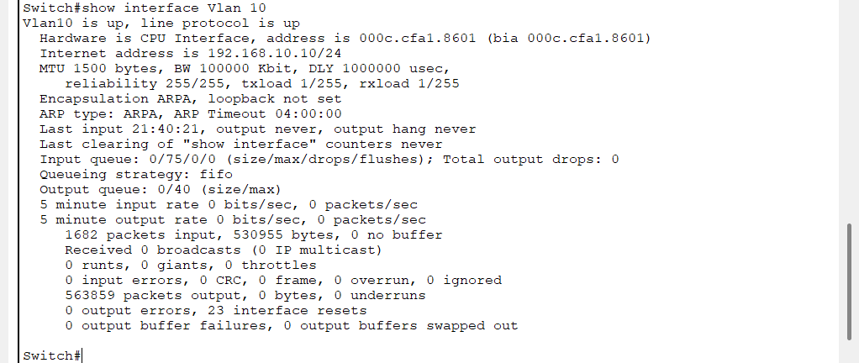
- Port assignment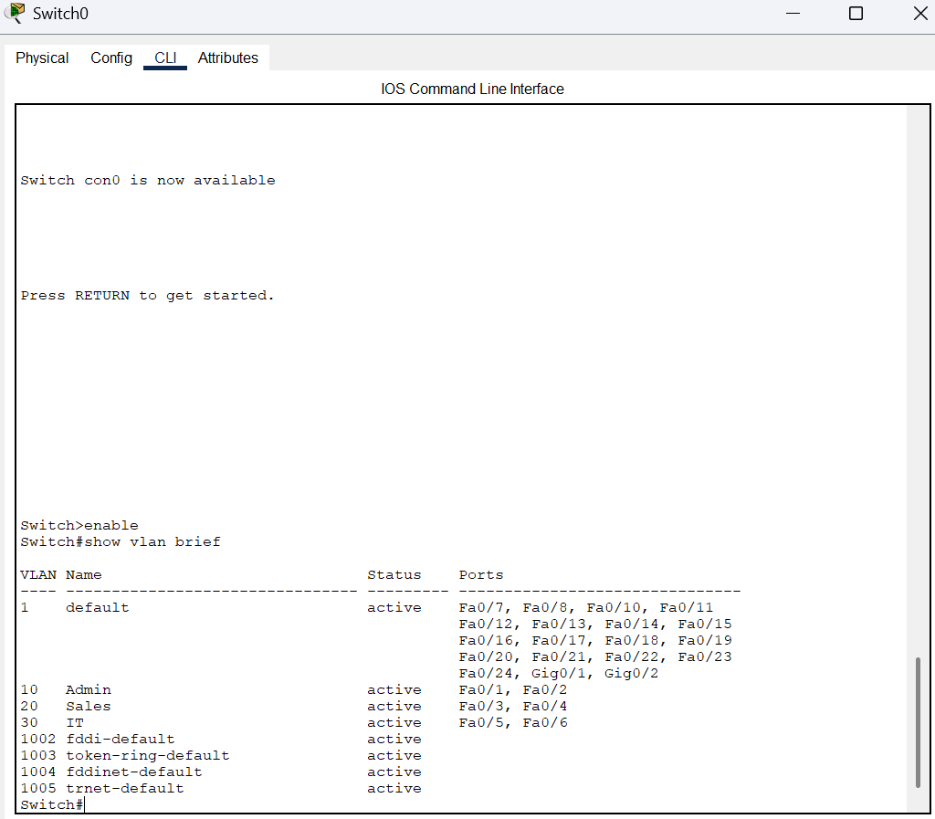
- Trunk Port
Configure the link to the router.
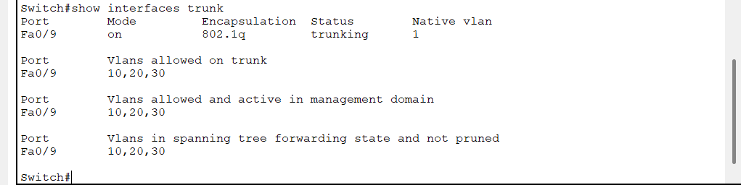
- Optimization
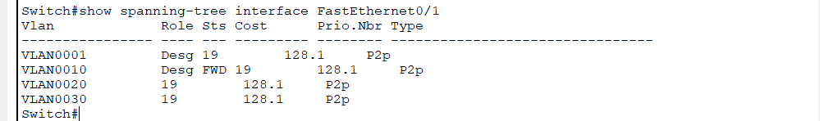

- Verify Connectivity by pinging and entering simulation mode.
